Project Title
Employee Raise Issue – Record Procedure
& Service Portal Integration Guide
Name : Bijjam Pravallika
College : Chalapathi Institute of Engineering and Technology
Email : y23cse016@chalapathiengg.ac.in

Project overview
The Employee Raise Issue – Record Producer & Service Portal Integration project focuses on simplifying and improving the process of raising employee issues in ServiceNow. By using ServiceNow’s custom application, tables, UI policies, Record Producer, Service Portal, and widgets, the solution provides employees with an easy way to submit workplace issues. The system stores issue details in a structured table, applies field dependencies and validation, and provides a self-service portal for submitting and managing requests. This improves issue tracking, data organization, user experience, and overall efficiency while reducing manual effort.
Table of Contents
1. Introduction
2. Project Objectives
3. Key Features
4. ServiceNow Developer Setup
5. Project Implementation in ServiceNow
6. Screenshots of Output
7. Conclusion
1. Introduction
The Employee Raise Issue – Record Producer & Service Portal Integration project is developed in ServiceNow to provide employees with a dedicated platform for reporting their issues. The application allows users to enter the required issue details through a structured form and submit them directly through the Service Portal.
The project uses a custom application, custom table and fields, UI Policies, field dependencies, Record Producer, Service Portal, and widgets to build the complete solution. The Record Producer simplifies the creation of issue records, while UI Policies and dependencies make the form more interactive and ensure that relevant information is captured based on the user's selections.

2. Project Objectives
The main objective of the Employee Raise Issue – Record Producer & Service Portal Integration project is to develop a structured and user-friendly system for employees to raise and manage workplace issues through ServiceNow. The project aims to make issue submission easier, organize employee information effectively, and provide a centralized platform for handling issues.
The system allows employees to submit their issues through a Service Portal using a Record Producer. The submitted information is stored in a custom table, while UI Policies and field dependencies help control the form based on the user's selections and ensure that the required information is provided.
The key objectives of the project are:
- To provide an easy and centralized platform for employees to raise issues.
- To simplify issue submission using a Record Producer.
- To store employee issue details in a structured custom table.
- To use UI Policies and field dependencies for better form functionality.
- To develop a user-friendly Service Portal for employees.
- To use widgets to improve the portal interface and functionality.
- To improve the organization, tracking, and management of employee issues.
- To demonstrate the use of ServiceNow application development and Service Portal features.
3. Key Features
• Custom Employee Issue Application for managing employee-raised Issues
• User-friendly Record Producer for submitting issues with required details.
• Custom table and fields to store and organize employee issue information.
• UI Policies to control field visibility, mandatory fields, and read-only fields.
• Field dependencies to display relevant options based on employee selection.
• Service Portal that provides employees with an easy self-service interface.
• Custom widgets to improve the portal's functionality and user experience.
• Structured issue tracking through centralized ServiceNow records.
• Reduced manual effort and improved organization in handling employee.

4. ServiceNow Developer Setup:
Access the ServiceNow Developer Portal
1. Go to ServiceNow Developer
Portal(https://developer.servicenow.com/dev.do).
Sign up for a free developer account and fill out the following details.
2. After signing up, you will get a verification mail to your provided email id.
After the verification your ServiceNow Developer Portal Home Page will
appear.
3. Now click on start building it will take you to the section where you can
request a Personal Developer Instance (PDI) or start using App Engine Studio
and other tools.
4. Profile Icon(Top Right Corner) →Manage your account, request instances,
and check your developer profile.

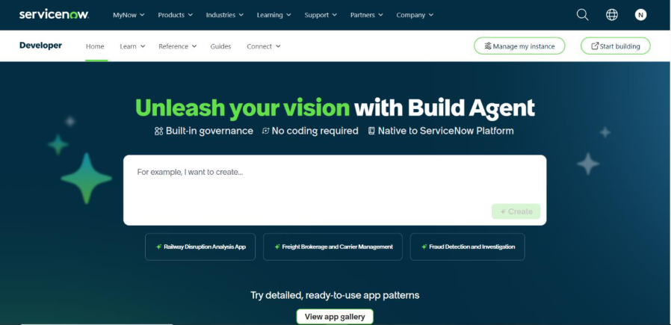
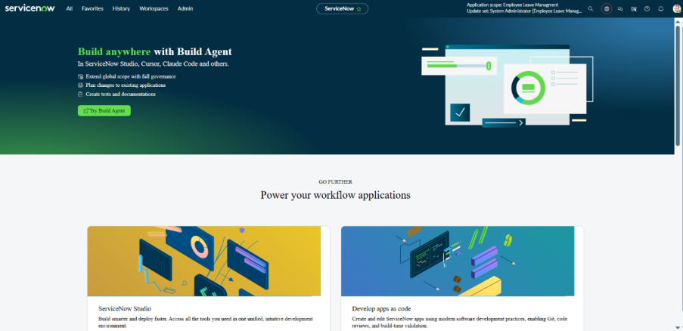
5. Project Implementation in ServiceNow:
After the instance building is completed, the page will be directed into your
Creator Studio.
Creator Studio in ServiceNow provides a guided, no-code environment to
build applications quickly. It is especially used for creating request-based
applications by defining forms, setting up tables, and automating workflows.

Phase1:Creating a custom Application
a. Create An Application
• Navigate to Application Navigator.
• Click on All and search for ServiceNow Studio.
• Under App Engine, open ServiceNow Studio.
• Click on the Create button.
• Select the App option to create a new application.
• Fill in the application details:
Name: Employee Center
Scope: Scoped
• Click on Continue to create the application.
• Return to the ServiceNow Home page.
• Reload/refresh the page.
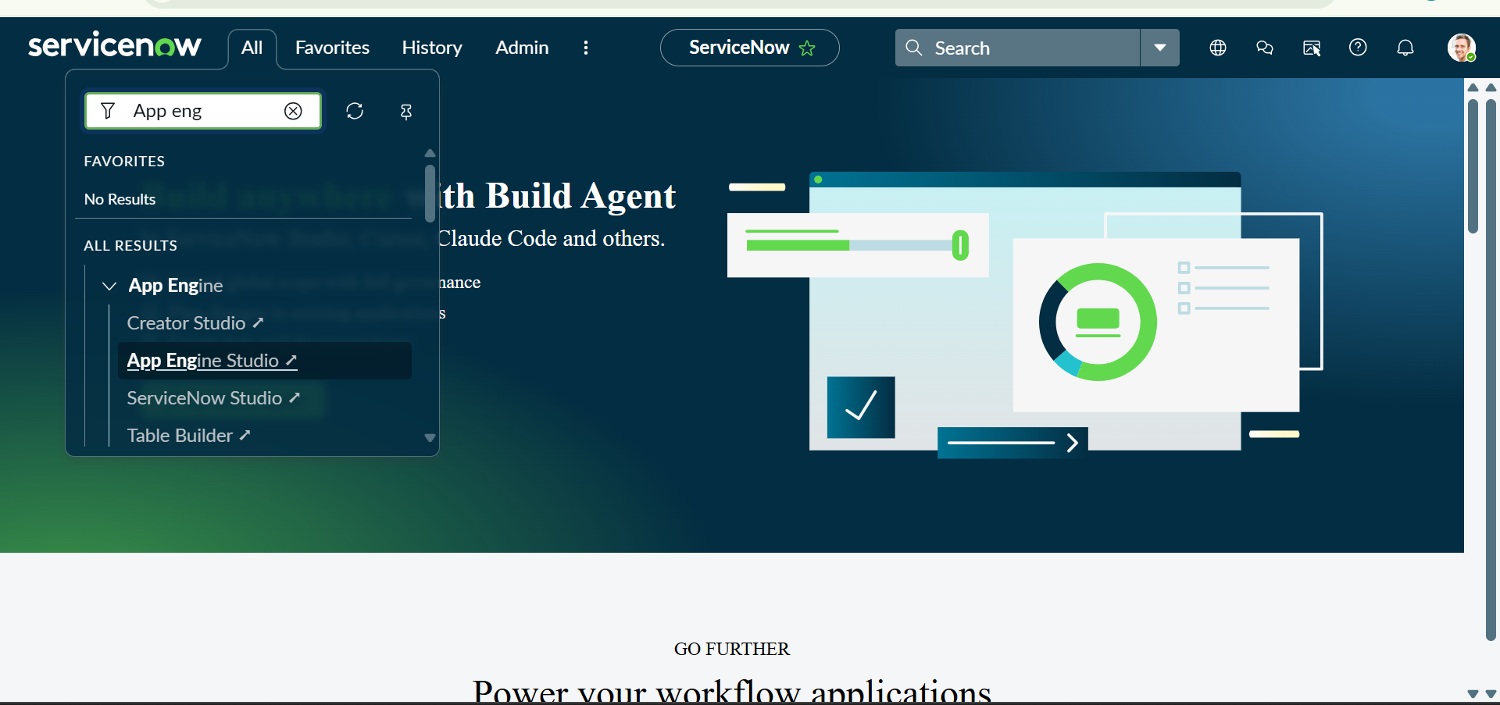
• Verify that Employee Centre appears as the Current Application. Click on New

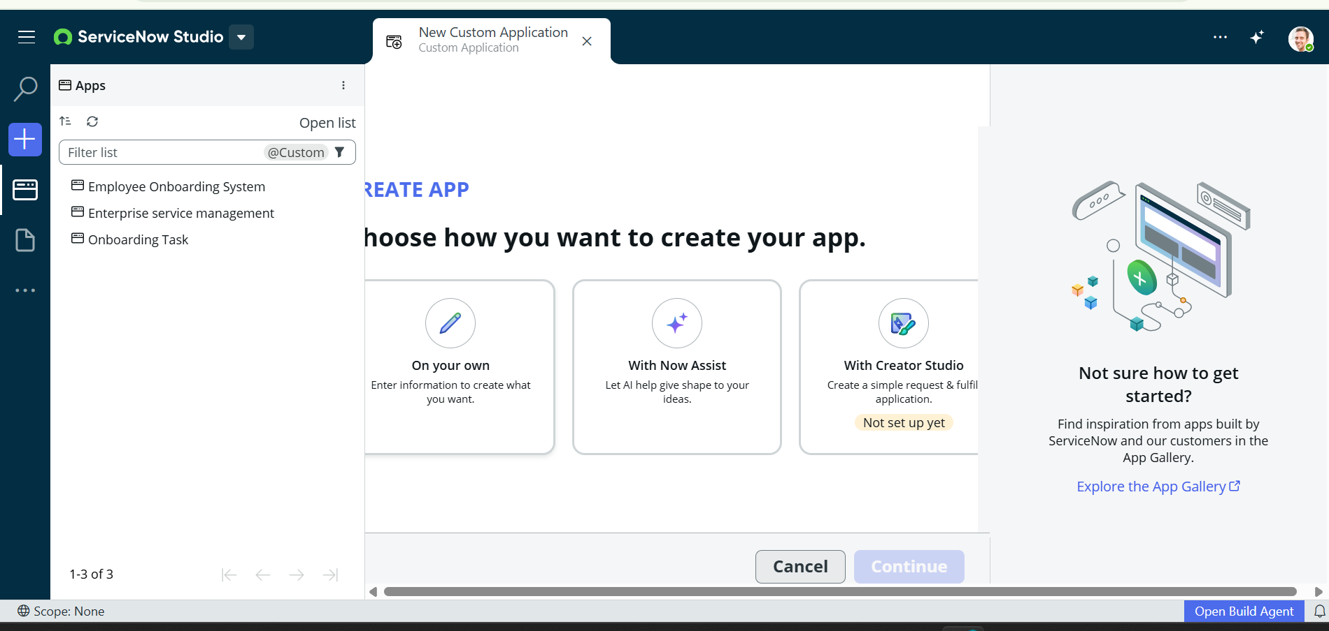
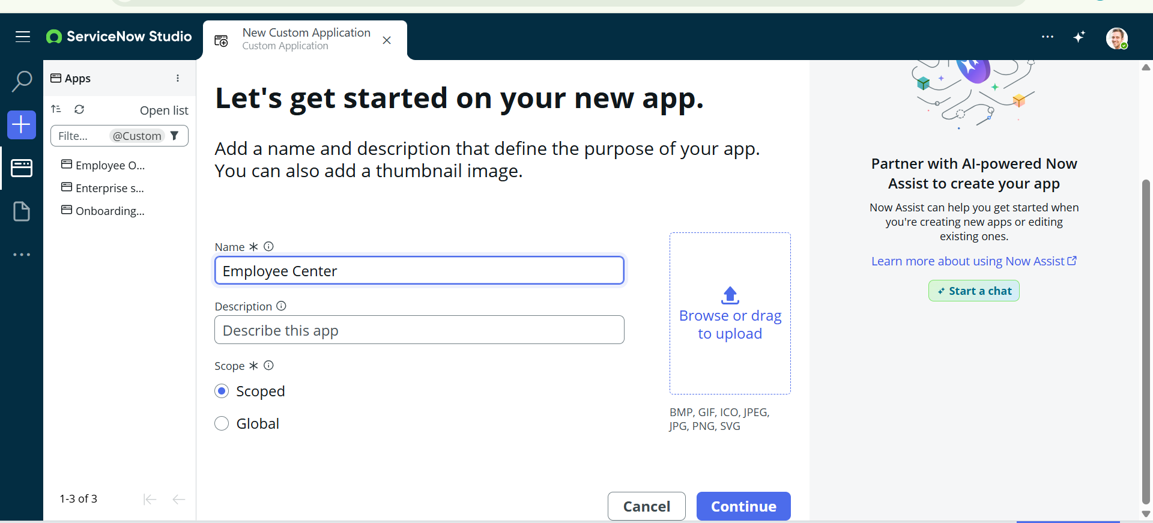
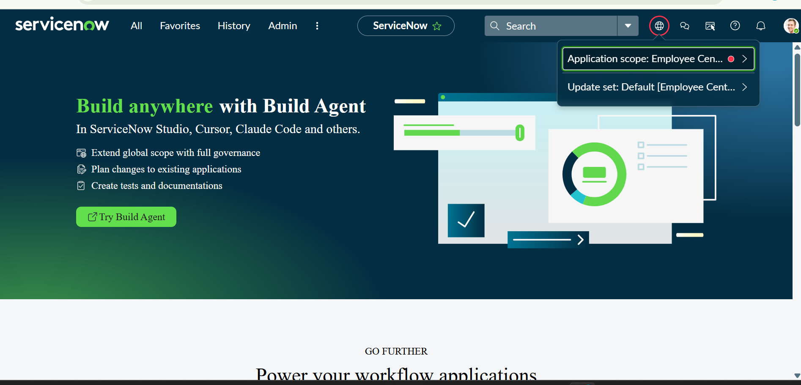

Phase2:Creating a custom Tables & Fields
a. Navigation Steps:
• Navigate to Application Navigator.
• Click on All and search for Tables.
• Under System Definition, select Tables.
• Click on the New button in the top-right corner.
• Fill in the table details:
Label: Employee Raises Issue
Name: Automatically populated by ServiceNow.
• Under the Controls section, enable Auto Number.
• Review the table settings and ensure the required options are selected.
• Open the Context Menu (three-dot menu) at the top of the form.
• Click Save to create the table.

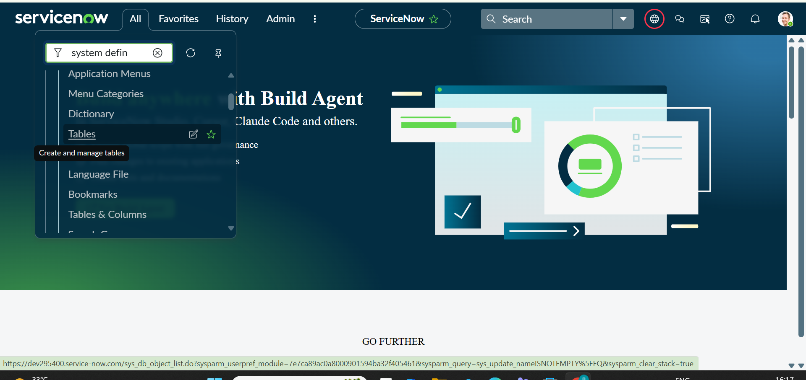
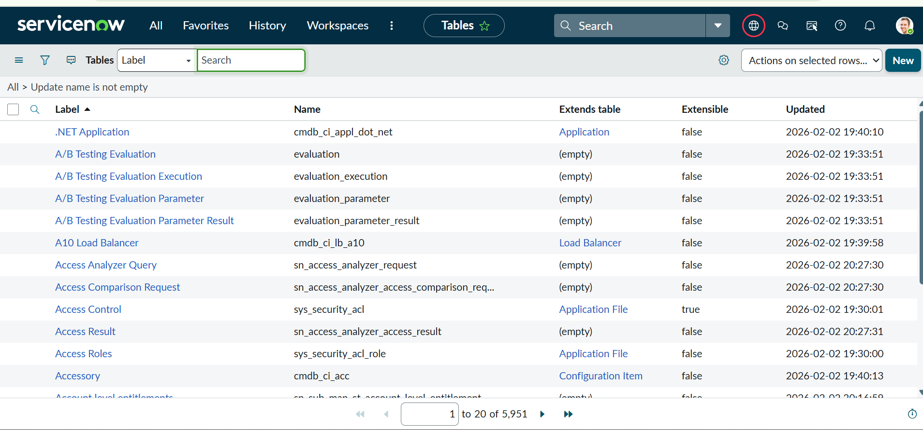
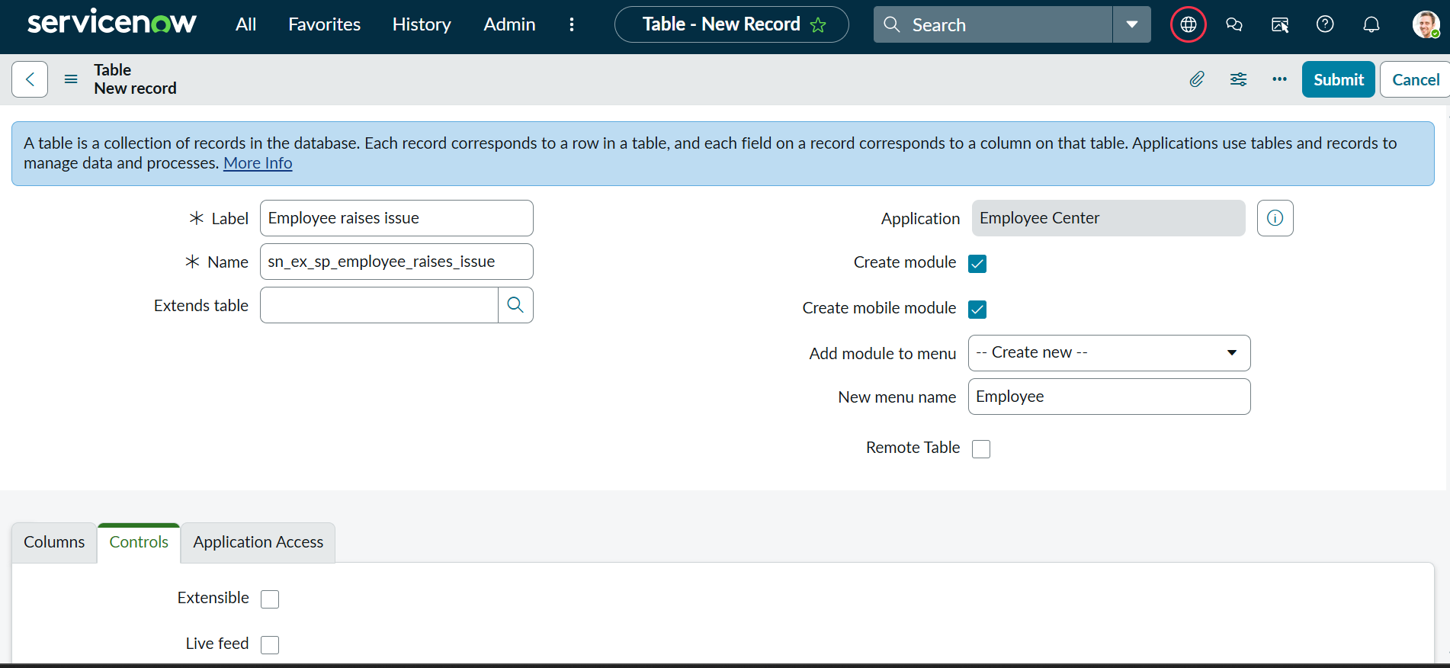

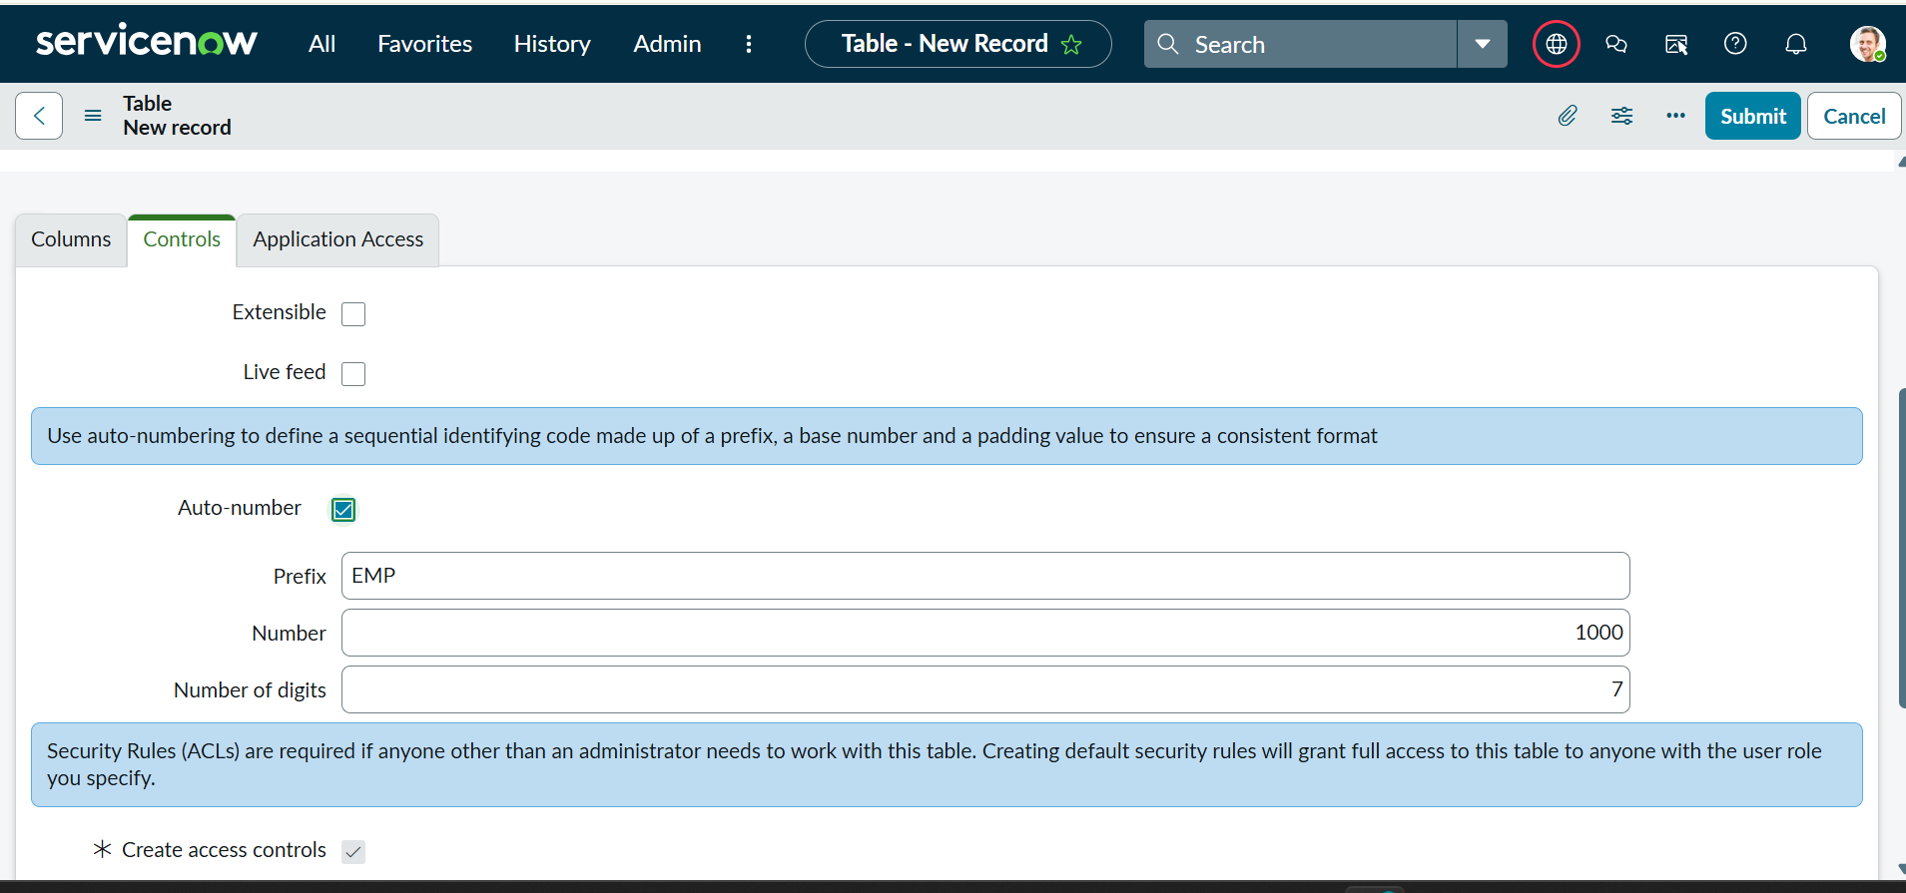
b: Creating Fields
- In the Related Links section, select Show Form.
- Open the form's Context Menu.
- Navigate to Configure → Form Design.
- Add the required fields to the form according to the specified field names and types.
- Configure the following fields:
Field Label | Type | Notes
Number | Auto-Number | —
Requester | Reference | References the sys_user table
Category | Choice | Network, Hardware, Software, Access
Subcategory | Choice | VPN, Laptop, Server, Forgot password
Short Description | String | —
State | Choice | New, In Progress, Resolved, Closed
Priority | Choice | Critical, High, Medium, Low
Assignment Group | Reference | References the sys_user_group table
- Arrange the fields in the required order using Form Design.
- Save the form configuration and verify that all fields are displayed correctly.
- Subcategory: VPN, Laptop, Server, Forgot Password
- State: New, In Progress, Resolved, Closed
- Priority: Critical, High, Medium, Low
- Save the field configurations.
- Verify that all the newly created fields are displayed correctly on the Employee Raises Issue form.

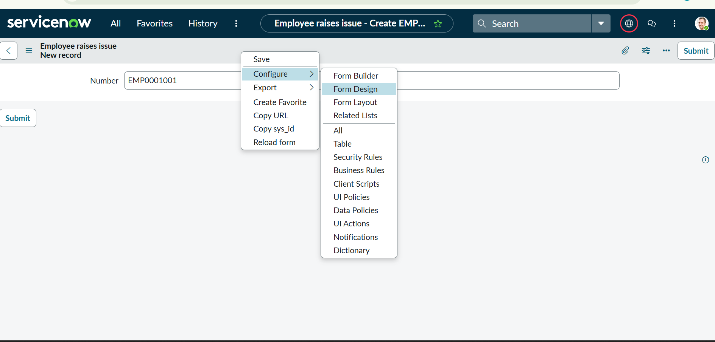
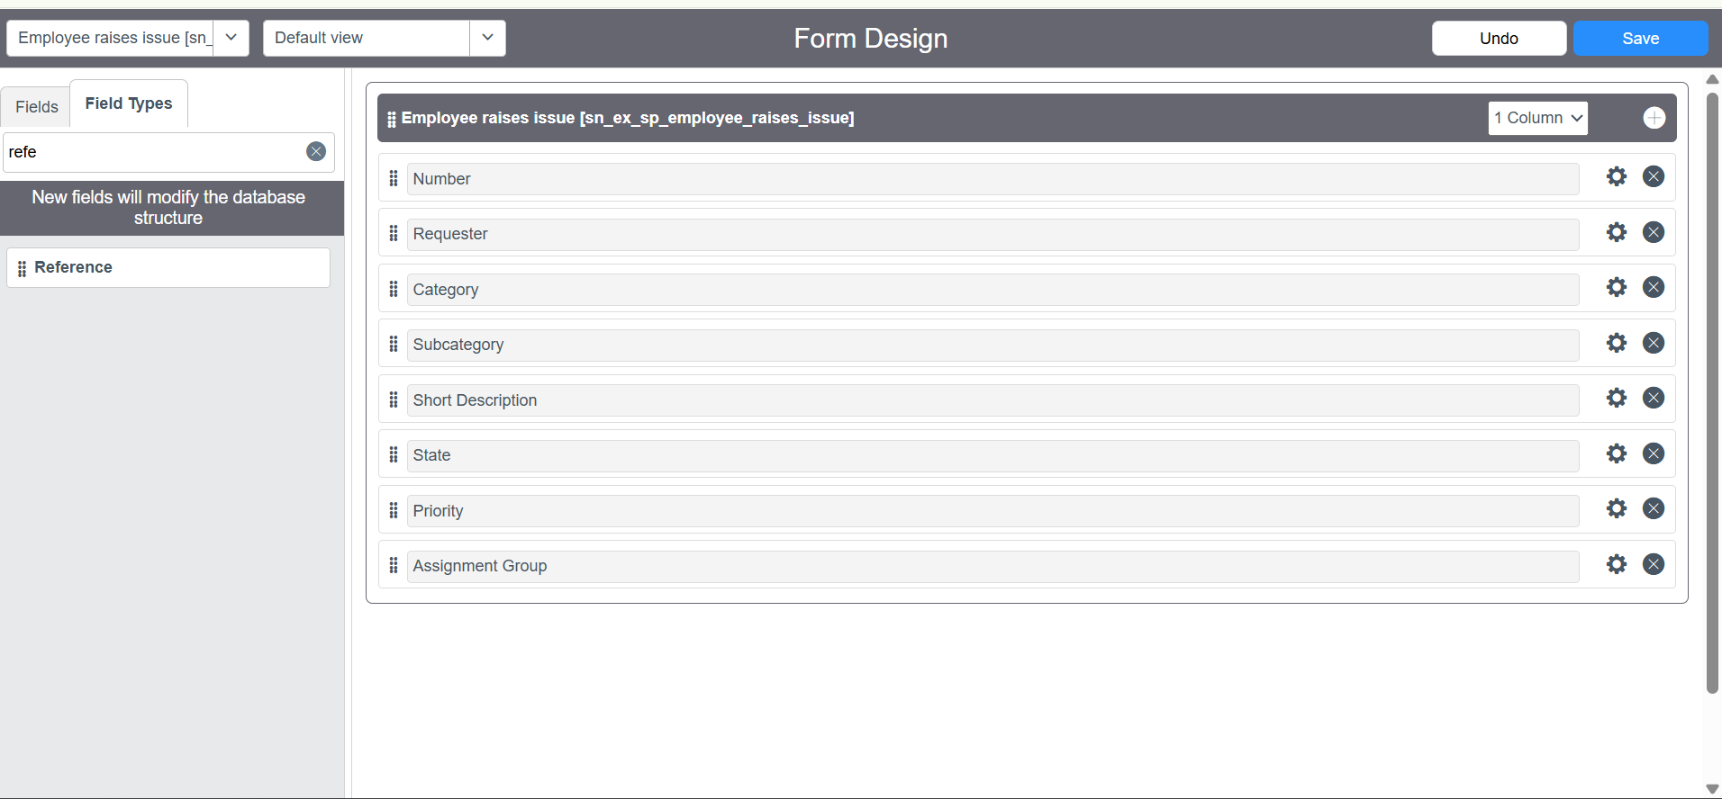
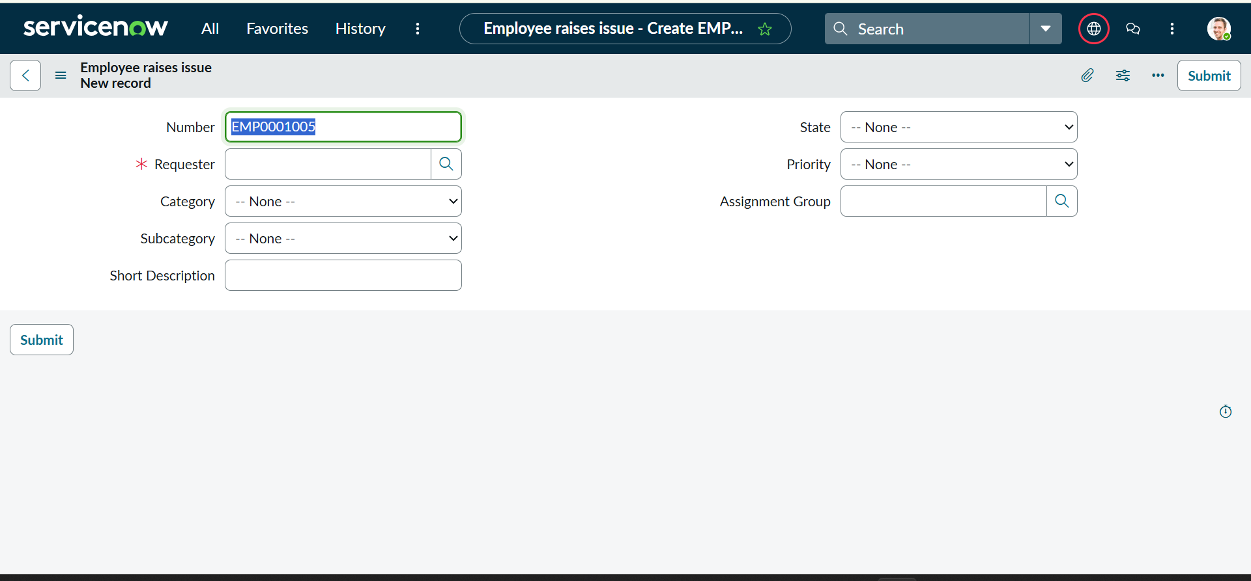

V: Catalog UI Policy Configuration
Scenario: If user selects types of devices is Others, then Please specify
field should populate.
Procedure:
1. Navigate to catalog items
2. Open Network Request item

Phase3:Creating UI Policies and Dependency
a: Creating UI Policies
1. Go to All → System UI → UI Policies or search for UI Policies in the All menu.
2. Click New in the top-right corner to create a new UI Policy.
3. Set the Table to Employee Raise Issue and enter the Short Description, such as: “When the state changes to New, Short Description is mandatory.” and Provide short description, if required
4. Under When to Apply, set the filter condition to State is New.
5. Save the UI Policy. In the Related Links, go to the UI Policy Actions section and click New.
6. Set Field Name to Short Description ,Mandatory to True and Read Only unchanged
7. Click Submit, then open the UI Policy and click Update to save the changes.
8. Open the Employee Raise Issue form, reload the page, change the State to New, and verify that Short Description becomes mandatory.
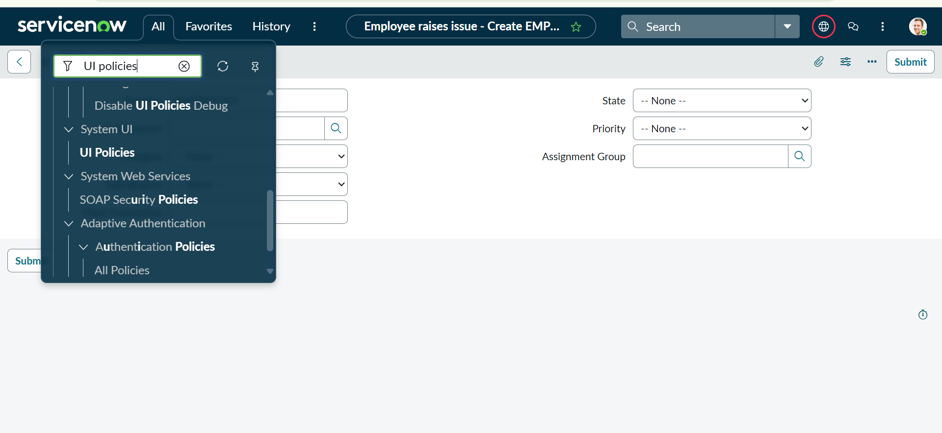
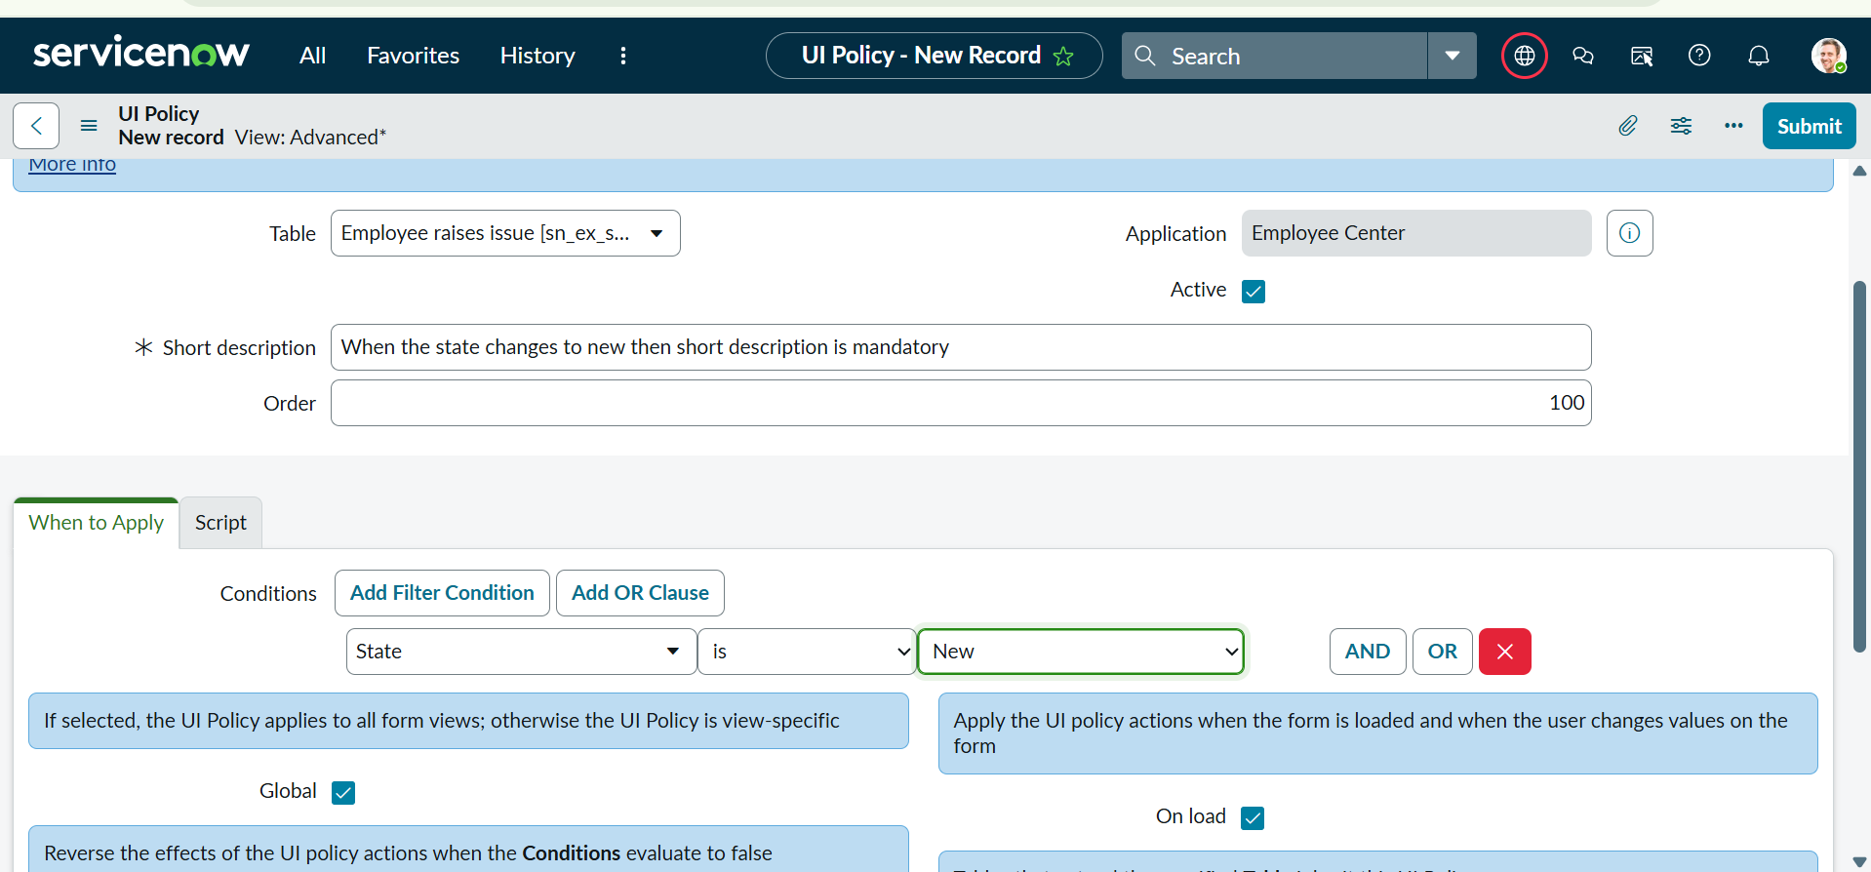
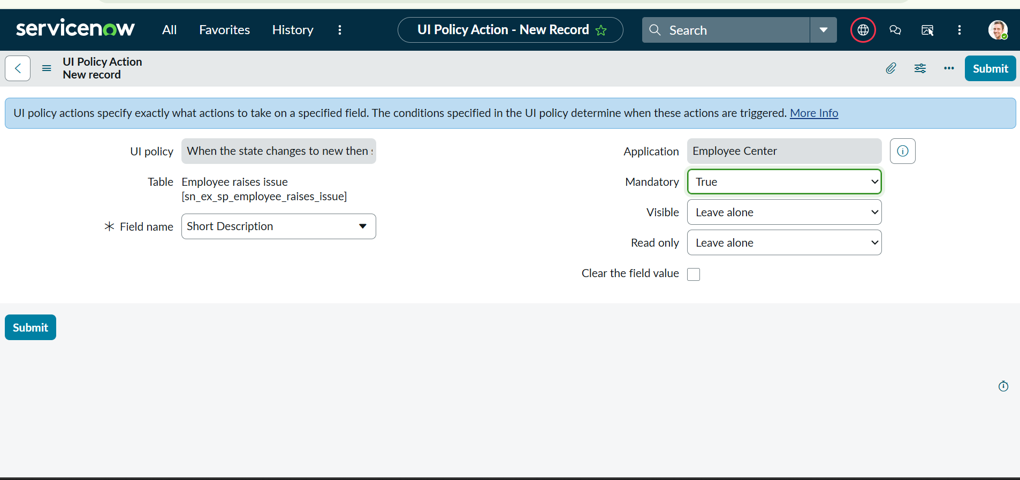

F. Making Number field Read only
- Navigate to UI Policies and click New in the top-right corner.
- Set Table to Employee Raise Issue and Short Description to “Number field will be read-only.”
- Leave the Filter Condition empty and save the UI Policy.
- Under Related Lists → UI Policy Actions, click New and select Number as the field.
- Set Read Only to True, while leaving Mandatory and Visible unchanged.
- Click Submit, then click Update to save the changes.

b: Making Number field Read only:
- Navigate to UI Policies and click New in the top-right corner.
- Set Table to Employee Raise Issue and Short Description to “Number field will be read-only.”
- Leave the Filter Condition empty and save the UI Policy.
- Under Related Lists → UI Policy Actions, click New and select Number as the field.
- Set Read Only to True, while leaving Mandatory and Visible unchanged.
- Click Submit, then click Update to save the changes.
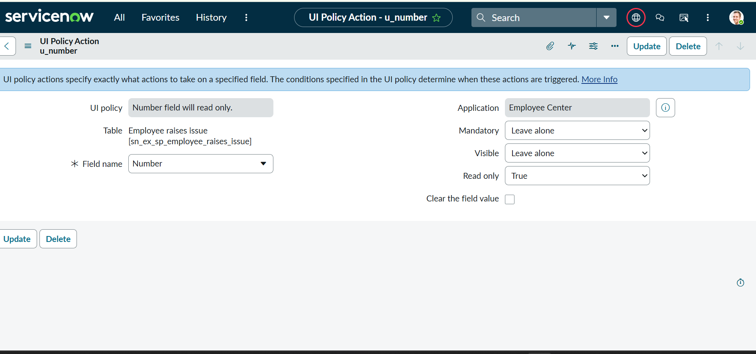
c: Creating Dependency
- Open the Employee Raise Issue table form, right-click Subcategory, and select Configure Dictionary.
- Open Advanced View under Related Links and set Category as the Dependent Field.
- Under Related Links → Choices, configure the Subcategory choices using the backend names of the corresponding Category values.
- Set the dependencies as Network → VPN, Hardware → Laptop, Software → Server, and Access → Forgot password.
- Verify that the appropriate Subcategory value is displayed automatically based on the selected Category.

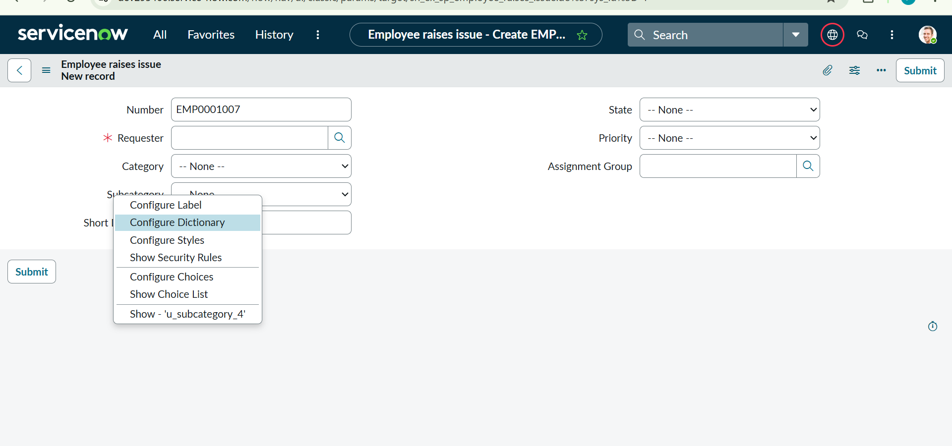
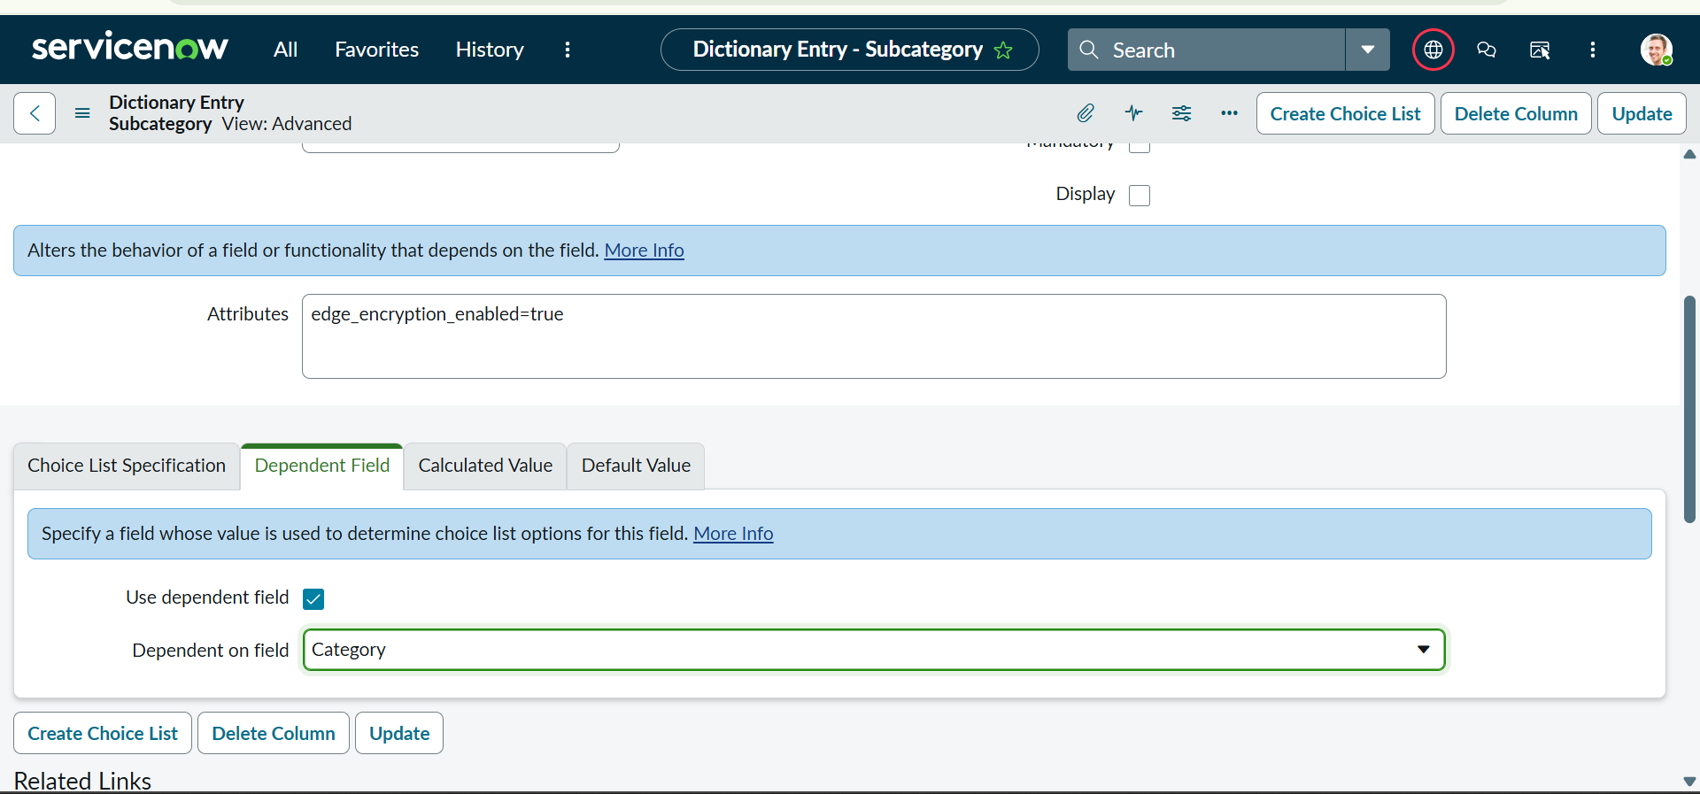
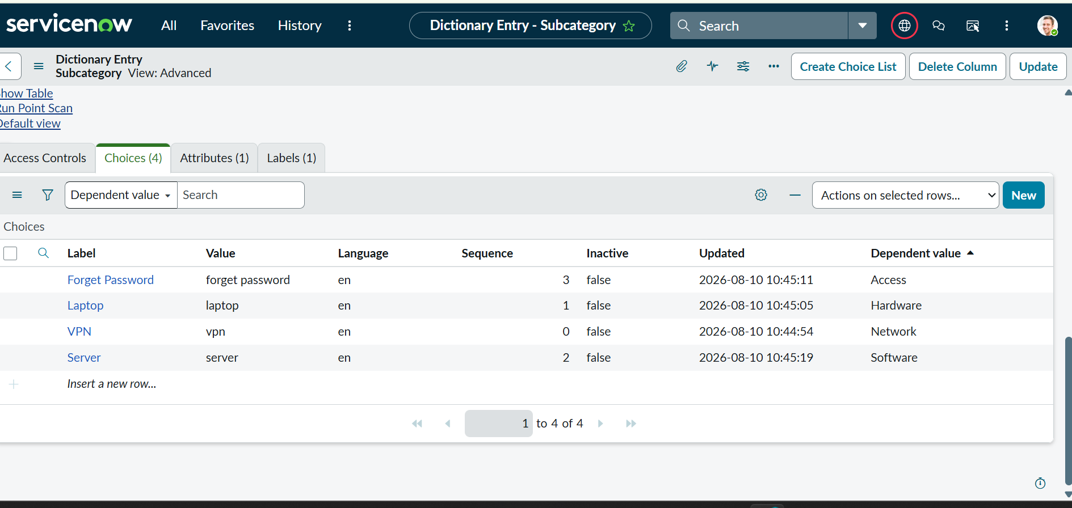
Phase4:Creating a Record Producer
a: Creating a Record Producer
- Navigate to All → Service Catalog → Catalog Definition → Record Producers and click New.
- Enter Name: Raise Employee Issue, select Table: Employee Raise Issue, and add a suitable description under What it will contain.
- In Accessibility, select Catalog: Service Catalog, Category: Service, add an image in Picture, and enter the Table Name as the Meta name.
- Save the Record Producer, then under Related Links → Variables, click New to create the required variables.
- Select each variable type according to the Employee Raise Issue table, enable Map to Field, choose the corresponding field and type, and assign orders 100, 200, 300, 400, 500.
- Enter each variable's question in the Question field, allowing the Name to populate automatically, and create all five variables.
- Configure the variables as Requester – Reference (sys_user), Category – Choice (Network, Software, Hardware, Access), Subcategory – Choice (VPN, Laptop, Server, Forgot password), State – Choice (New, In progress, Resolved, Closed), and Short Description – Single Line Text/String.
- Save the form and verify that all five variables are created and mapped correctly.
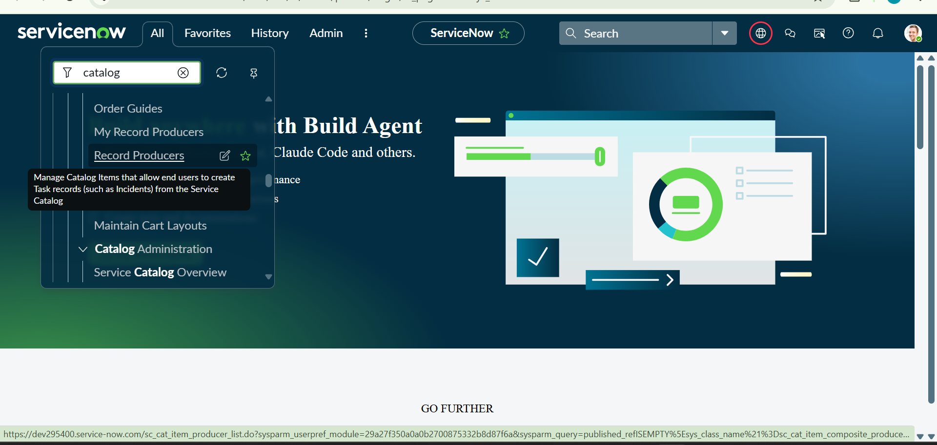
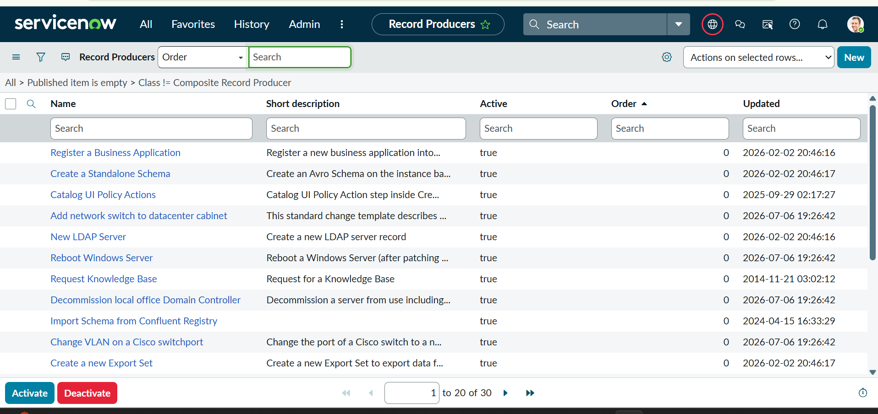

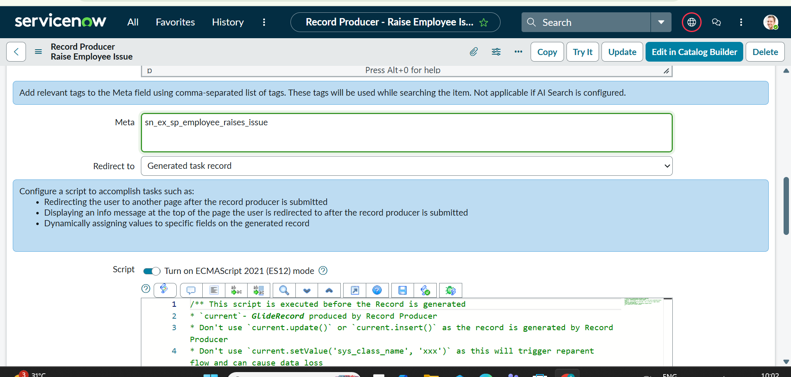
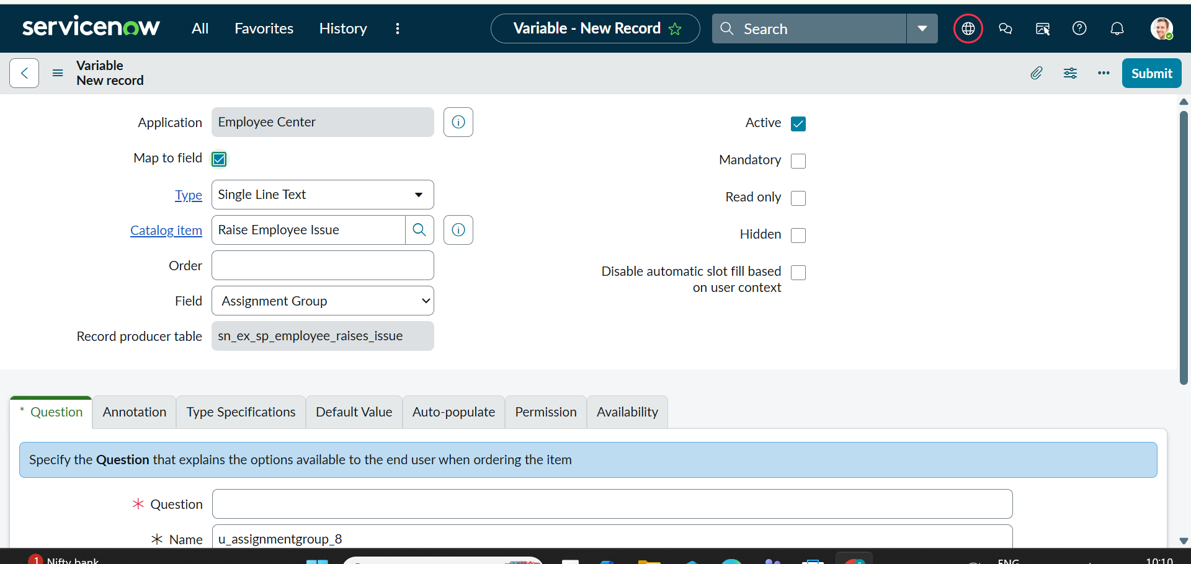
Now open a new tab with this link {https://dev280178.service-now.com/}.
Add Suffix as (sp). And search with the table name in the search bar.
Then it displays in the way of the picture below.

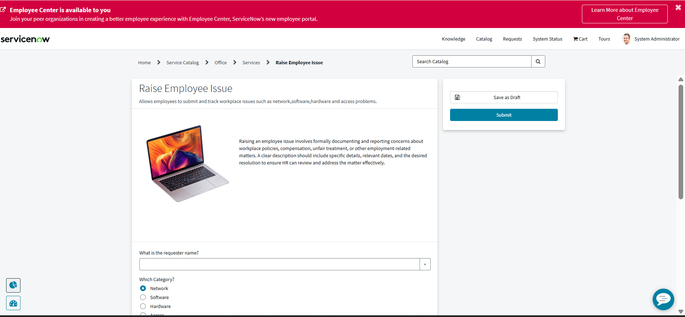

Phase 5:Creating a new Service Portal
a: Creating a new Service portal
- Navigate to Service Portal → Service Portal Configuration and click New to create a portal.
- Set Title: Requesting Portal and URL Suffix: employee_request.
- Select Homepage: ec_standard_home, KB Home Page: esc_knowledge_home, and Login Page: login.
- Upload the required Logo and select Main Menu: Employee Center Menu.
- Set 404 Page: 404 and Theme: Employee Center Coral Theme, then save the portal.
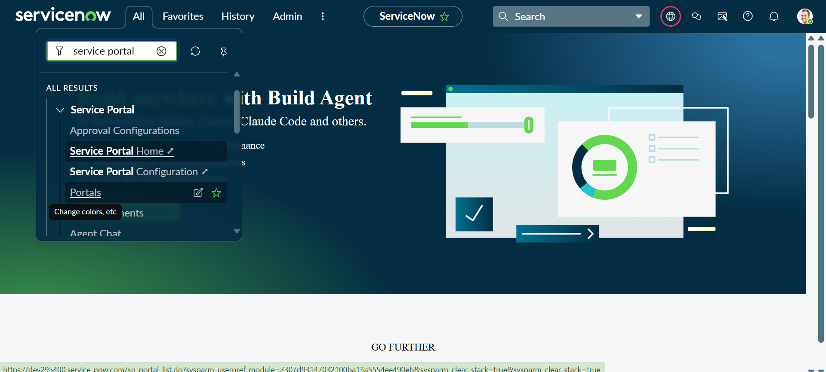
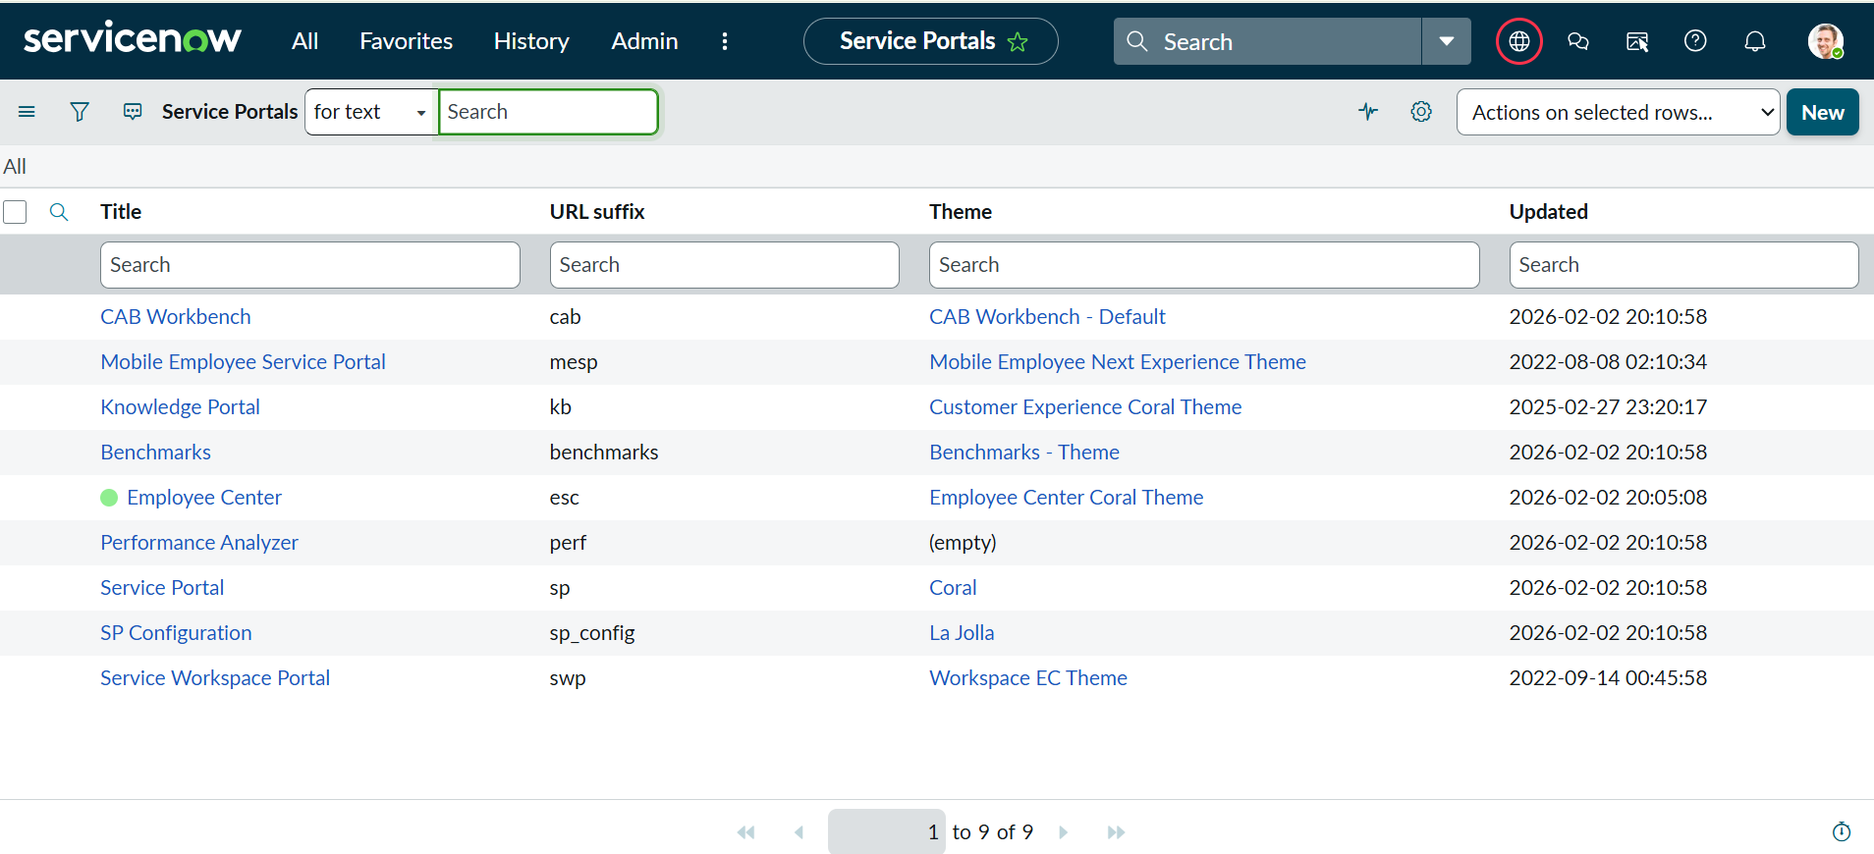
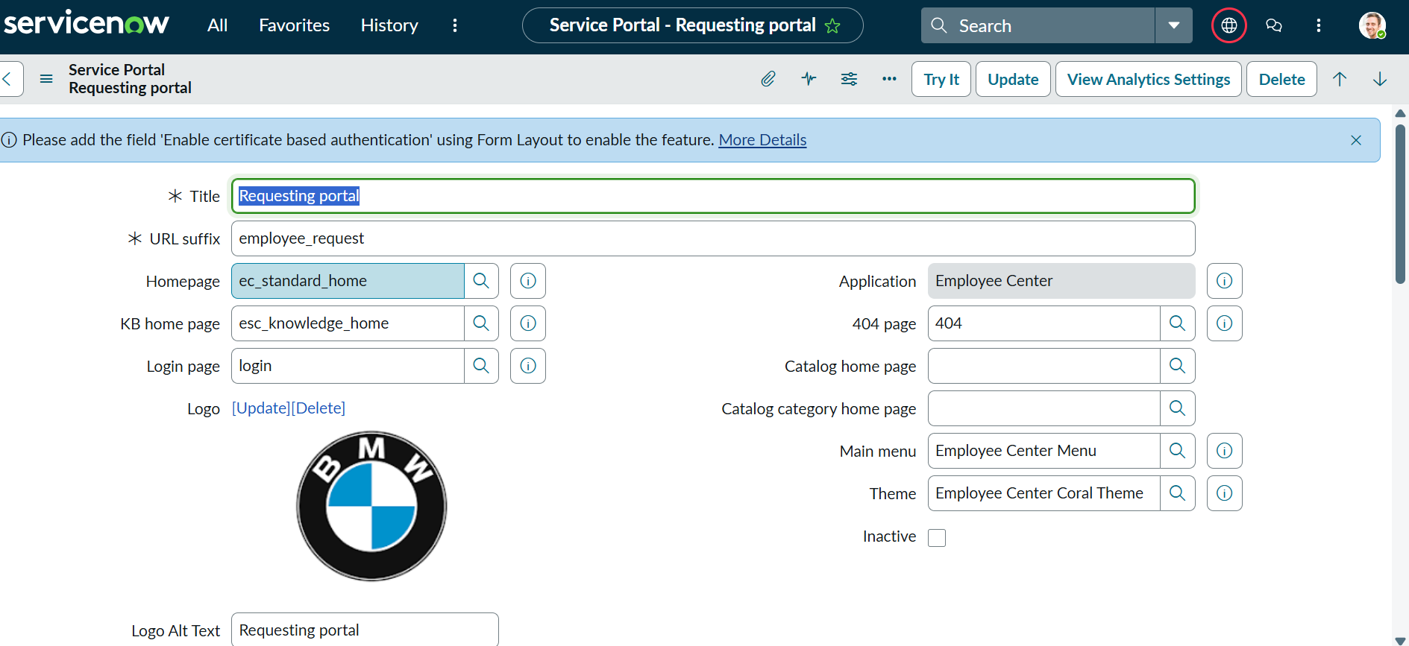
b: Creating A New Employee Center Portal Page
- Navigate to All → Service Portal → Pages and click New in the top-right corner.
- Enter Title: Employee Center Portal Page and ID: employee_center_portal_page, then click Save from the Context Menu.

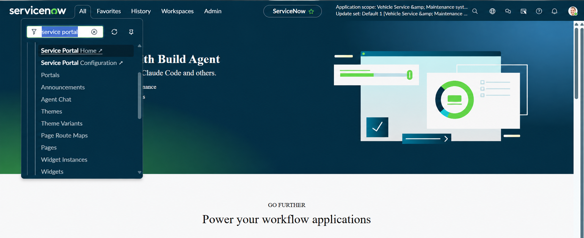
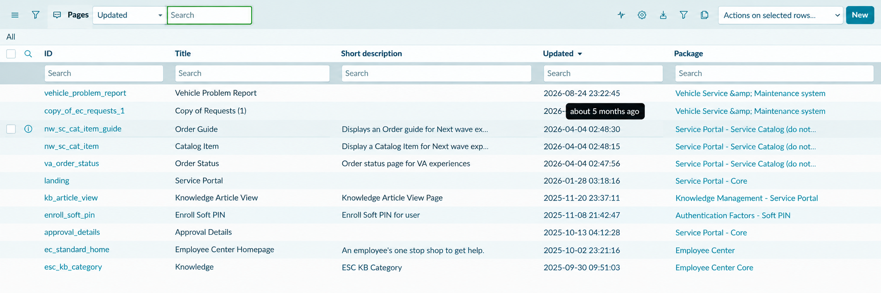
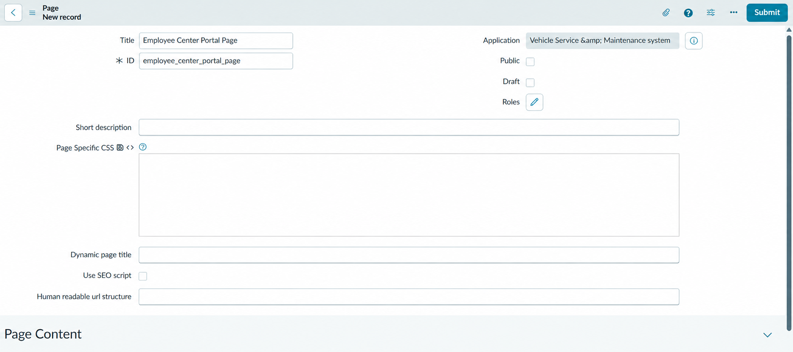
Phase6:Creating Widgets and Adding to the page
a: Left Widget Creation
- Navigate to Service Portal Configuration → Service Portals, open Widget Editor, and click Create a New Widget.
- Enter Widget Name: Commercial Widget and click Submit.
- Enable the HTML and CSS templates and add the required code in each section.
- Use the Eye icon to show or hide the Preview while designing the widget.
- Configure the widget with floating words that move based on cursor movement, then save and verify the preview.
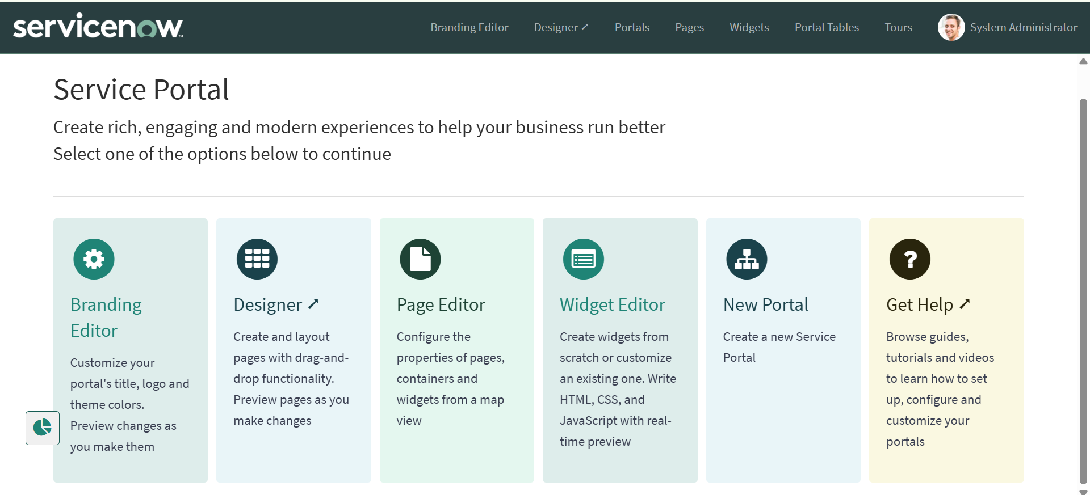
HTML Code:
<div class="commercial-widget">
<h2>Our Commercial Services</h2>
<p>
We provide end-to-end IT services, support, and issue resolution
through a streamlined Service Portal experience.
</p>
<ul>
<li>✔ 24/7 Customer Support</li>
<li>✔ Faster Issue Resolution</li>
<li>✔ Transparent Tracking</li>
<li>✔ Secure & Reliable</li>
</ul>
</div>
CSS Code:
/* =============================== COMMERCIAL WIDGET – ALL IN ONE =============================== */ .commercial-widget { background: linear-gradient( 135deg, #1db954 0%, #ffffff 50%, #0b5ed7 100% ); padding: 30px; border-radius: 14px; box-shadow: 0 10px 25px rgba(0, 0, 0, 0.12); height: 100%; position: relative; overflow: hidden; transition: transform 0.4s ease, box-shadow 0.4s ease; } /* Hover floating card */ .commercial-widget:hover { transform: translateY(-8px); box-shadow: 0 20px 40px rgba(0, 0, 0, 0.18); } /* Floating animated background glow */ .commercial-widget::before { content: ""; position: absolute; top: -50%; left: -50%; width: 200%; height: 200%; background: radial-gradient( circle, rgba(255, 255, 255, 0.25) 0%, transparent 60% ); animation: floatBg 8s infinite linear; pointer-events: none; } /* Floating background animation */ @keyframes floatBg { from { transform: rotate(0deg); } to { transform: rotate(360deg); } } /* Floating heading text */ .commercial-widget h2 { color: #0b5ed7; margin-bottom: 15px; font-weight: 700; position: relative; animation: floatText 3s ease-in-out infinite; } /* Heading animation */ @keyframes floatText { 0% { transform: translateY(0); } 50% { transform: translateY(-6px); } 100% { transform: translateY(0); } } /* Paragraph styling */ .commercial-widget p { color: #222; font-size: 15px; margin-bottom: 18px; } /* List styling */ .commercial-widget ul { padding-left: 0; list-style: none; } /* Animated list items */ .commercial-widget ul li { padding: 10px 0; font-size: 14px; color: #222; opacity: 0; animation: slideIn 0.8s ease forwards; } /* Staggered animation */ .commercial-widget ul li:nth-child(1) { animation-delay: 0.2s; } .commercial-widget ul li:nth-child(2) { animation-delay: 0.4s; } .commercial-widget ul li:nth-child(3) { animation-delay: 0.6s; } .commercial-widget ul li:nth-child(4) { animation-delay: 0.8s; } /* Slide-in effect */ @keyframes slideIn { from { opacity: 0; transform: translateX(-15px); } to { opacity: 1; transform: translateX(0); } } /* =============================== OPTIONAL CROSS-WIDGET EFFECT (Both widgets in same row) =============================== */ .row:hover .commercial-widget, .row:hover .raise-ticket-widget { transform: translateY(-5px) scale(1.01); } .
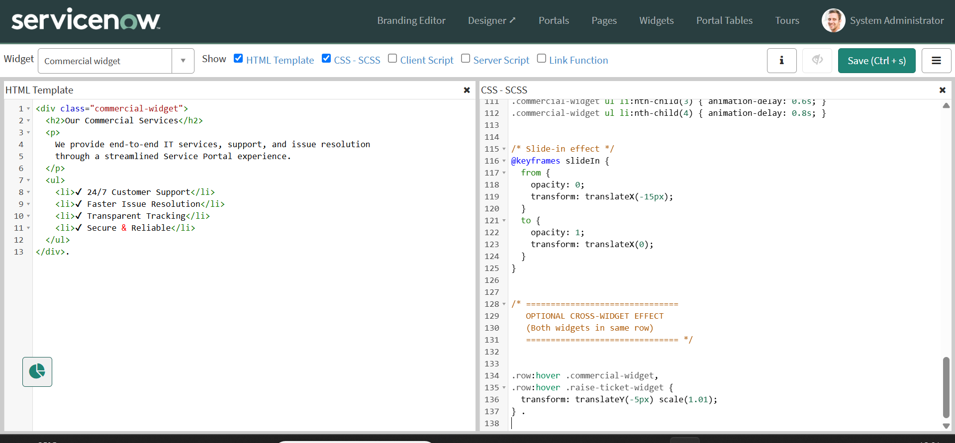
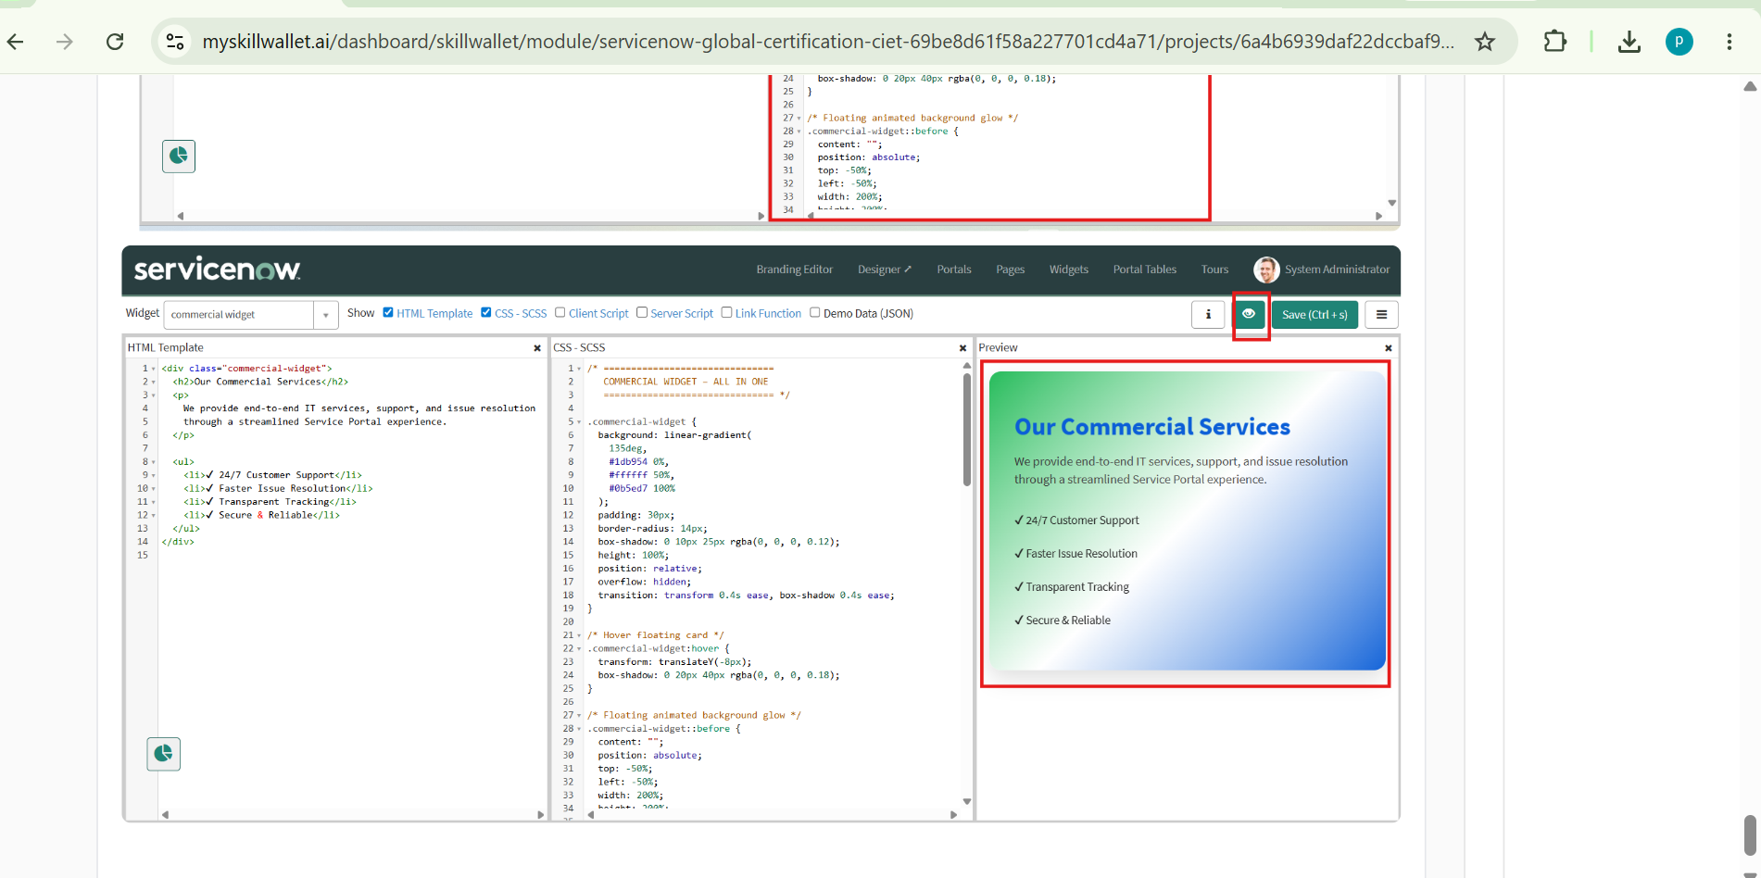
b: Right Widget Creation
- Navigate to Service Portal Configuration → Service Portals, open the Widget Editor, and click Create a New Widget.
- Enter Widget Name: Link Redirect and click Submit.
- Enable the HTML, CSS, and Client Script templates and add the required code, using the Client Script with the Record Producer sys_id to redirect the page.
- Use the Eye icon to show or hide the Preview while designing the widget.
- Configure the widget with floating words and premium effects based on cursor movement, then save and verify the preview.
HTML Code:
<a
href="javascript:void(0)"
class="raise-ticket-widget"
ng-click="c.openRecordProducer()"
>
<div class="overlay">
<h2>Raise an Issue</h2>
<p>Submit your request or complaint</p>

<span class="premium-btn">
Raise Ticket →
</span>
</div>
</a>
CSS Code:
/* ===============================
RAISE TICKET – PREMIUM WIDGET
=============================== */

.raise-ticket-widget {
display: block;
height: 100%;
min-height: 280px;
border-radius: 16px;
background-image: url('https://images.unsplash.com/photo-1553877522-43269d4ea984');
background-size: cover;
background-position: center;
text-decoration: none;
position: relative;
overflow: hidden;
transform-style: preserve-3d;
transition: transform 0.5s ease, box-shadow 0.5s ease;
box-shadow: 0 15px 35px rgba(0, 0, 0, 0.25);
}

/* Floating 3D effect */
.raise-ticket-widget:hover {
transform: translateY(-12px) scale(1.02);
box-shadow: 0 30px 60px rgba(0, 0, 0, 0.4);
}

/* Overlay with gradient */
.raise-ticket-widget .overlay {
background: linear-gradient(
135deg,
rgba(11, 94, 215, 0.85),
rgba(0, 0, 0, 0.75)
);
height: 100%;
width: 100%;
color: #fff;
display: flex;
flex-direction: column;
justify-content: center;
align-items: center;
text-align: center;
transition: background 0.4s ease;
}

/* Text styles */
.raise-ticket-widget h2 {
font-size: 24px;
font-weight: 700;
margin-bottom: 8px;
}

.raise-ticket-widget p {
font-size: 15px;
opacity: 0.9;
margin-bottom: 18px;
}

/* Premium button */
.raise-ticket-widget .premium-btn {
padding: 12px 28px;
border-radius: 30px;
font-size: 14px;
font-weight: 600;
color: #0b5ed7;
background: linear-gradient(135deg, #ffffff, #e9f1ff);
box-shadow: 0 10px 20px rgba(0, 0, 0, 0.25);
transition: all 0.3s ease;
}

/* Button hover */
.raise-ticket-widget:hover .premium-btn {
transform: translateY(-3px);
background: linear-gradient(135deg, #e9f1ff, #ffffff);
box-shadow: 0 15px 30px rgba(0, 0, 0, 0.35);
}

/* Soft glow animation */
.raise-ticket-widget::before {
content: "";
position: absolute;
top: -50%;
left: -50%;
width: 200%;
height: 200%;
background: radial-gradient(
circle,
rgba(255, 255, 255, 0.18),
transparent 60%
);
animation: floatGlow 10s infinite linear;
pointer-events: none;
}

/* Glow motion */
@keyframes floatGlow {
from {
transform: rotate(0deg);
}
to {
transform: rotate(360deg);
}
}
Client Script
Description:
function ($scope, $location) {
var c = this;

var RECORD_PRODUCER_SYS_ID = 'ae2cd61183433210de6fc590ceaad3a4';

c.openRecordProducer = function () {
$location.url(
'sp?id=sc_cat_item&sys_id=' + RECORD_PRODUCER_SYS_ID
);
};
}
- Locate the third line of the code containing RECORD_PRODUCER_SYS_ID.
- Paste your Record Producer sys_id inside the quotation marks.
- Copy and paste the complete code into the created widget.
- Click Save to save the widget code.
- Click Enable Preview beside the Save button to view or hide the widget preview on the right side.
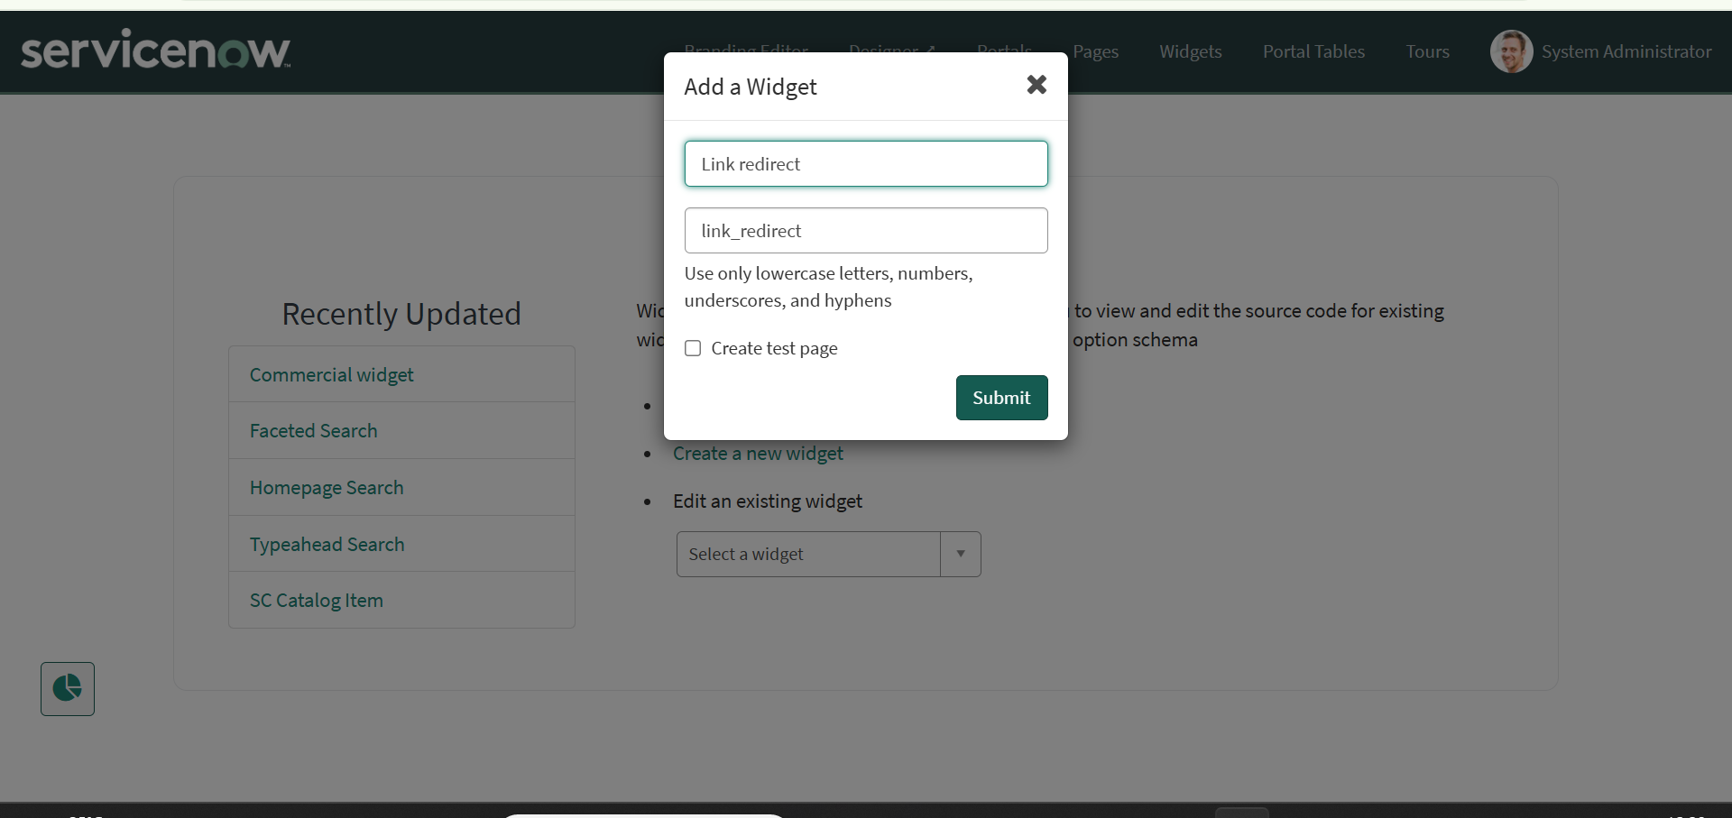

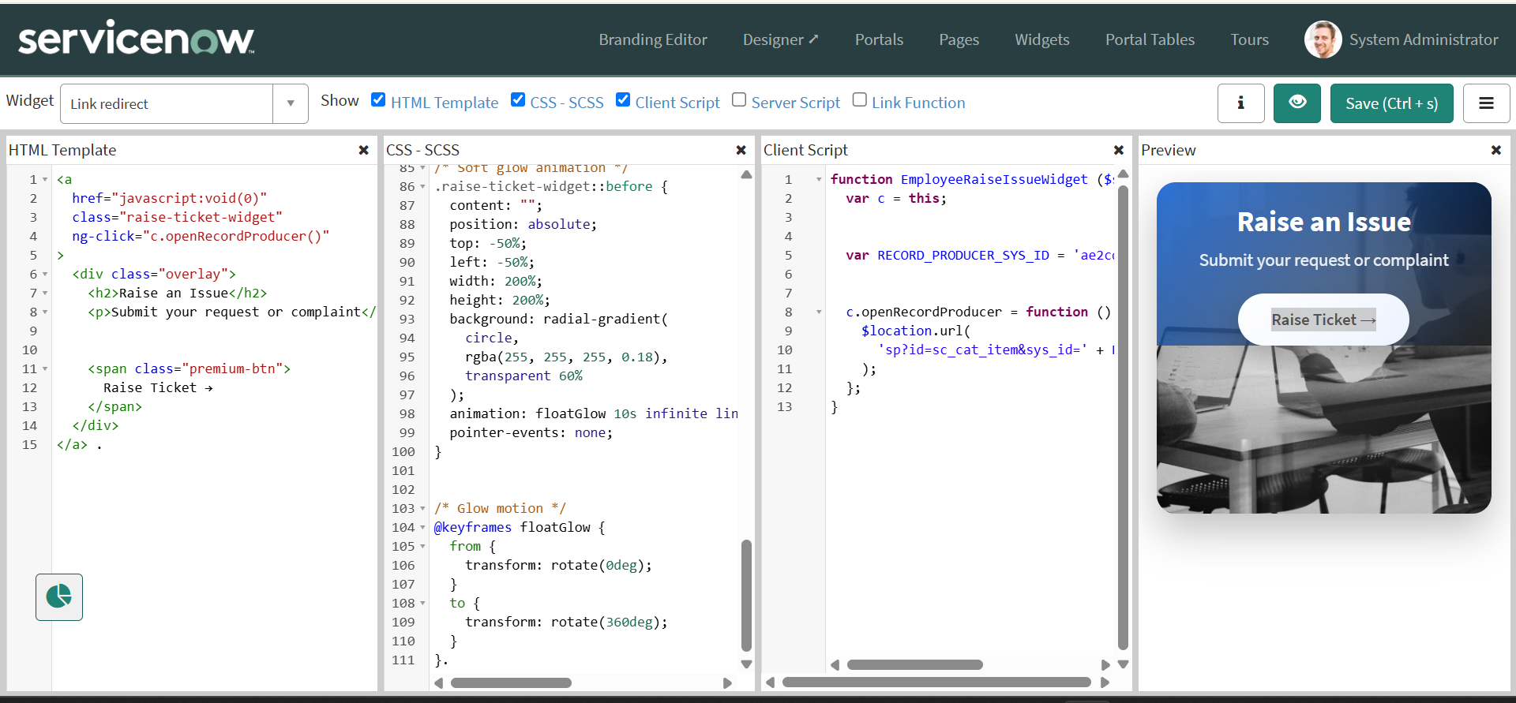

c: Adding 2 Widgets to the Page:
- Here we are using an already existing page.
- Page Name: Employee Center Portal Page.
- Navigate to Service Portal Configuration → Service Portal.
- Select the Designer.
- Search for the Employee Center Homepage and select it.
- Create a 6×6 container.
- Add the widgets based on which side we need to display them.
- Search for the required widgets and drag and drop them.
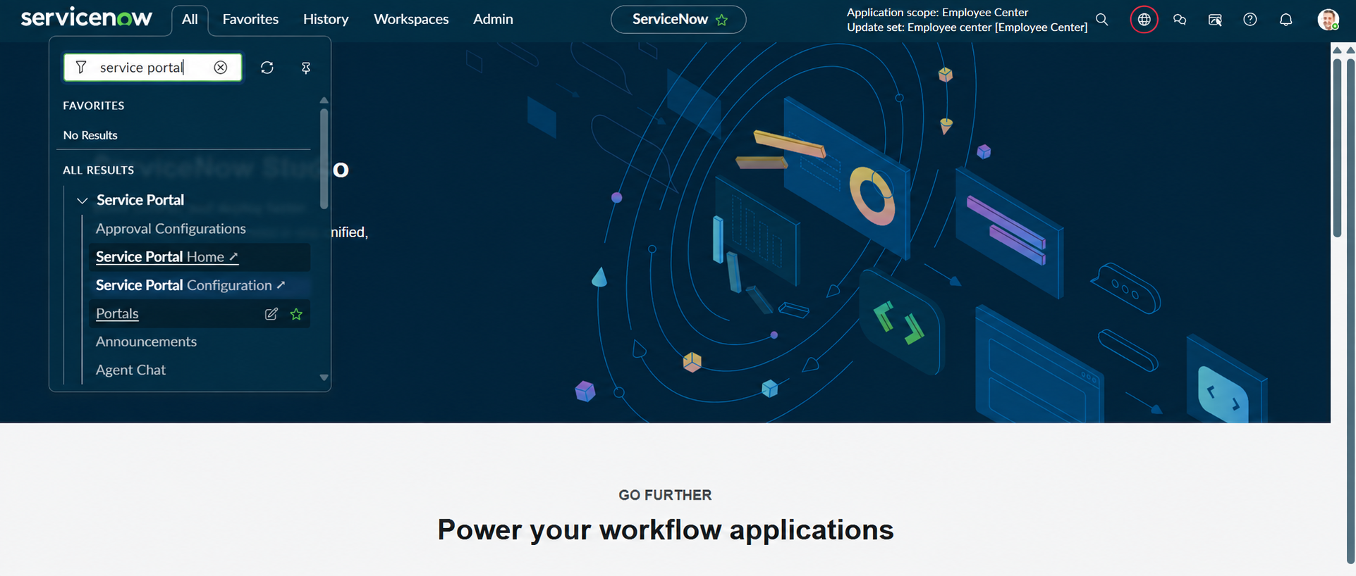
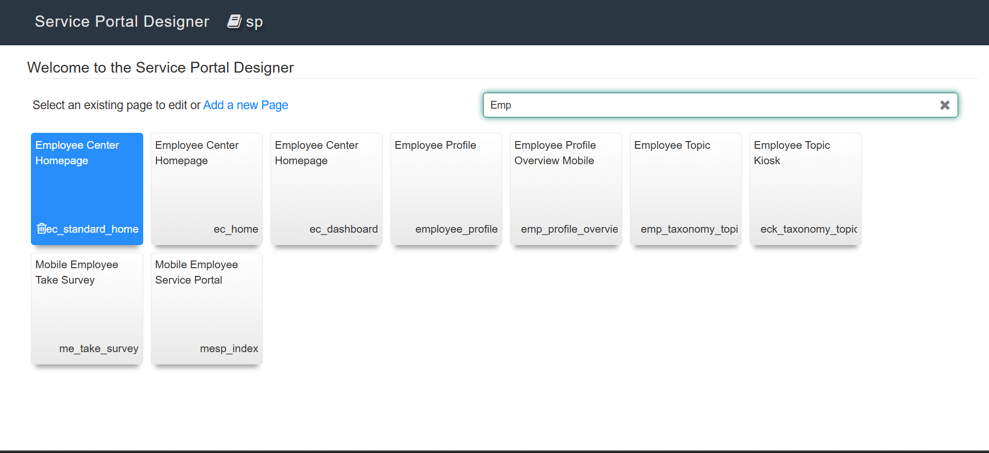
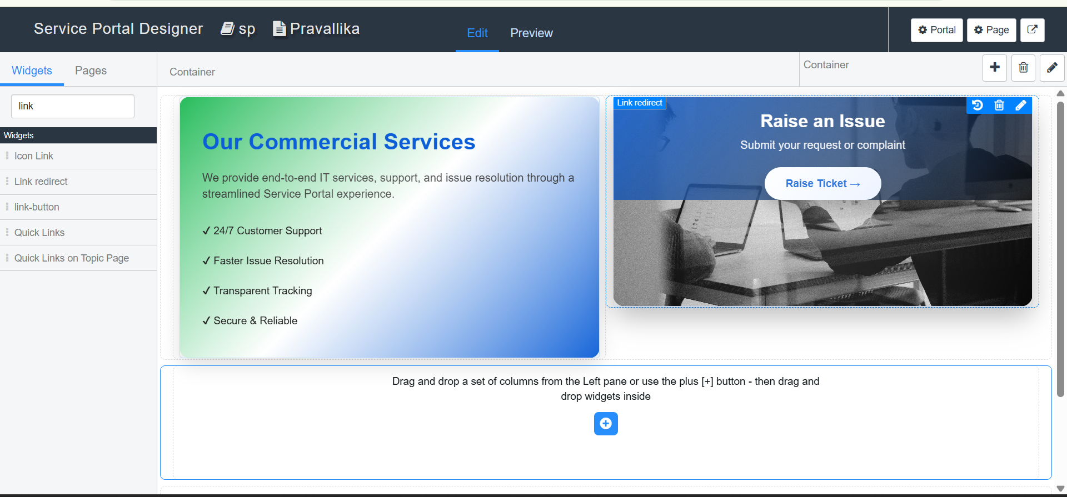

Phase7: Testing and Validation
- Open a new browser tab and paste the URL: https://dev280178.service-now.com/employee_request, then press Enter.
- Verify the added Image and Icon Picture, then scroll down to view the created widgets.
- Move the cursor to observe the floating effects of both widgets.
- Click the Link/Raise Ticket button to open the Record Producer and enter the employee and issue details.
- Click Submit and verify the field changes and restrictions configured through UI Policies and Dictionary Override.
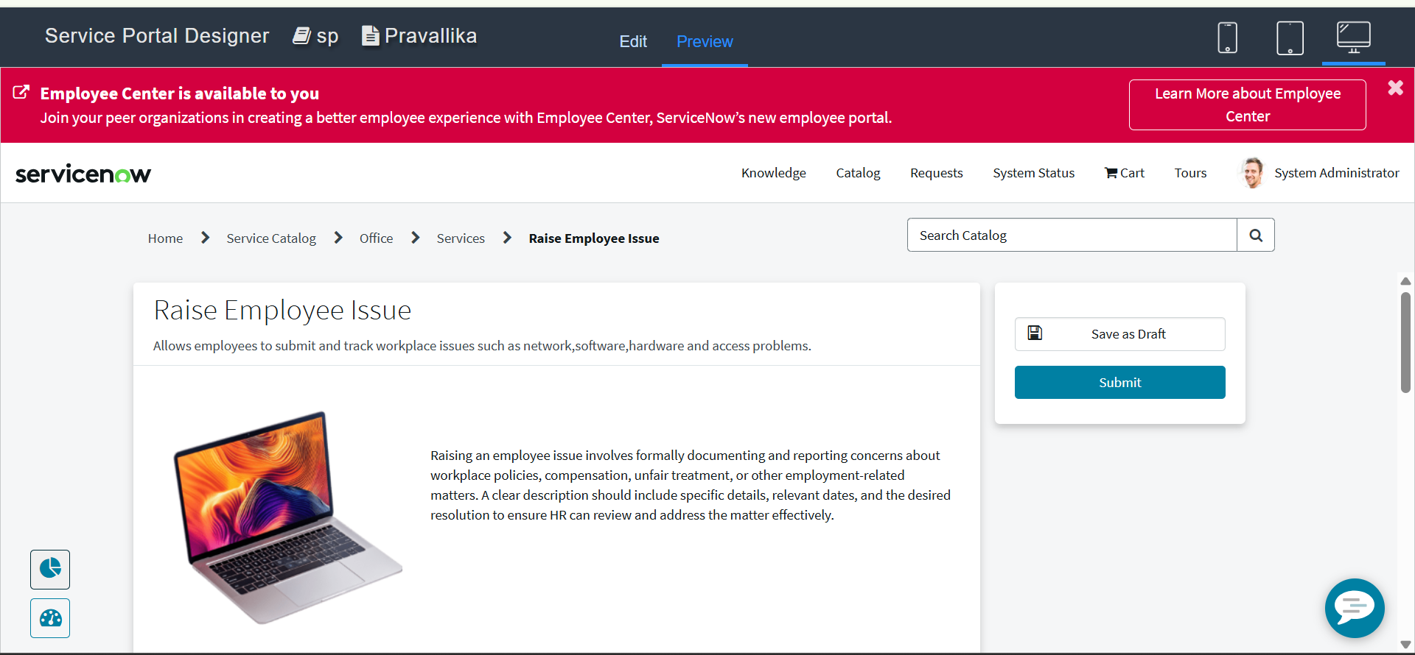

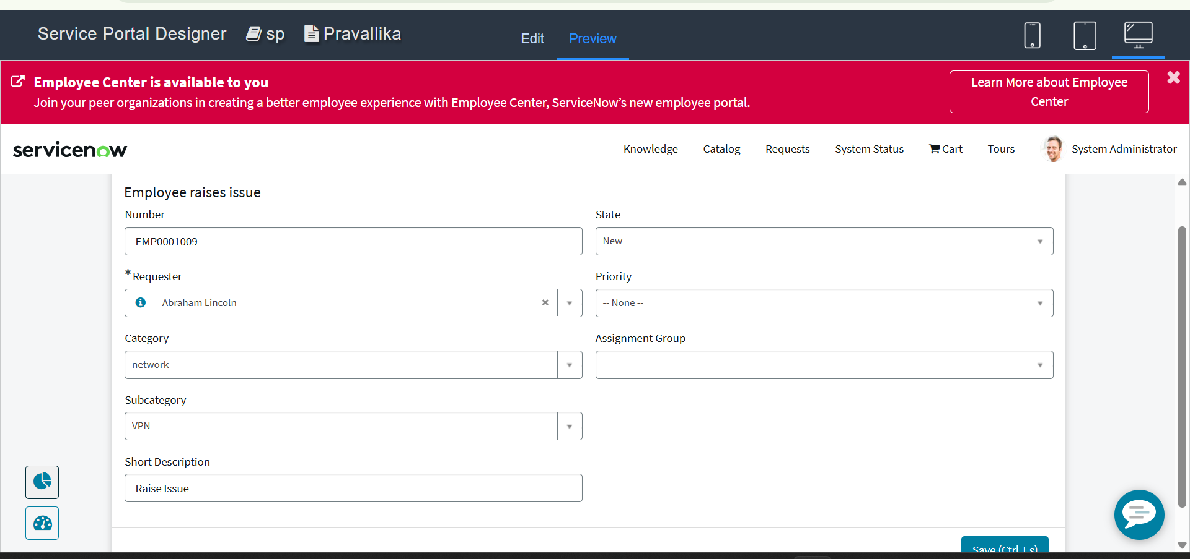
Phase8:Conclusion
The Employee Raise Issue project successfully provides a structured and user-friendly solution for employees to report workplace issues through ServiceNow. The integration of a custom application, table, UI Policies, Record Producer, and Service Portal ensures accurate data entry, controlled field selection, and proper issue management.
The project improves the employee experience by simplifying issue submission, reducing manual effort, minimizing data inconsistencies, and providing better visibility of submitted issues. The configured validations, dependencies, and testing confirm that the solution meets the required business needs and provides a reliable end-to-end issue reporting process.

